BIS 235 MIDTERM EXAM

Be brief while still being thorough. Strive to be as clear, precise, and concise in your answers as possible. Type and paste your responses directly in this document and then upload it when you are done. Paste diagrams from Visio or other drawing tool or simply hand draw them (neatly!) and paste a digital photo. Disorganized, illegible, or otherwise difficult to interpret output will be strongly penalized or ignored.

You have THREE HOURS to complete your exam. When you are done, please upload the exam directly to the quiz file upload provided. Your exam responses MUST be uploaded within three hours of the time that you started the exam.

1. **(10 pts) What is the main alternative to storing data in a database? List and discuss any 3 of the advantages database management systems provide over this alternative.**

The main alternative to storing data in a database is to store data physically on paper. One advantage to utilizing a DBMS is that data can easily be retrieved accurately. If data is not stored in a database, a user would have to physically review certain records and tally up the data that is needed. Another advantage is security and backup. If physical records were to be stolen, those records can be permanently lost if there aren’t any copies. Even if there are copies, maintaining those copies as backups can be extremely time consuming.

However, utilizing a DBMS eliminates the overall chance of your data be stolen or lost due or damage if the database is secured and backed up properly. Lastly, utilizing a database also promotes consistency. If certain tables are configured correctly, the data that is being fed to those tables for the most part is accurate. However, if a user is physically writing down certain records, human error will take effect and will affect the data consistency of the records.

1. **(5 pts) Describe an example of an issue related to transaction processing that having a DBMS makes easier to handle.**

An example could be that of an online store. With a DBMS any sales transactions are automatically recorded, and any additional information associated with that purchase is saved as well. This can make inventory easier due to the DBMS recording which items are in stock and which ones are not. This also promotes real time product analyzation as well. With a DBMS you can configure a report to see which items are being sold the most, from there you can decide if certain products should not be sold based on simple profit margin per sale thus improving your bottom line while streamlining your business.

1. **(5 pts) A college class can have multiple sections at a time, but a given section is of course only for one class. Sometimes a class has no sections. Draw an ERD with class for this situation. Note any assumptions you make.**

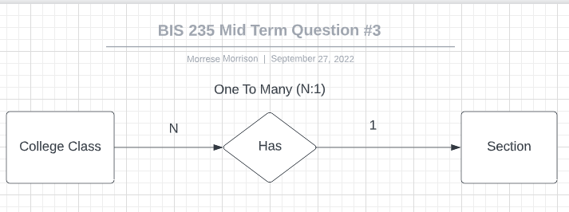

1. **(5 pts) Why and under what circumstances is a weak entity useful in entity-relationship modeling?**

A weak entity can be referred to as a subclass to the strong entity that it is has a relationship with. As such the weak entity depends fully on its participation to the strong entity because the weak entity does not have a primary key attached to it. An example would an employee and their dependents. The weak entity attributes may not be totally unique. In other words, multiple dependents may have the same first or last name that are linked to multiple employees.

Instead of collecting information that would require a primary key such as a social security number or a unique identifier, if the dependent entity is weak, it can contain those multiple same first and last names while still be unique due to those names belonging to a specific employee. This is useful since this practice downsizes the table as the information stored can be called upon in conjunction with the employee table, which cuts down the total number of primary keys but also promoting data availability.

1. **(20 pts) Draw an ER diagram with primary key based on the following problem statement. Include any relationship attributes, but you may omit non-key entity attributes. State any assumptions you make.**

A bank is interested in a new database to track loans. The bank’s many branch offices grant the loans. Customers apply for these loans. A loan is associated with at most one branch. Some loans (such as those that customers apply for over the Internet) aren’t associated with any branch. Multiple customers can apply for the same loan. An individual customer may apply for multiple loans. Some of the bank’s branches do not grant loans at all. The bank maintains information on some prospective customers that have never applied for a loan. The bank is interested in every customer’s social security number, name, address and phone number. Each branch has a branch number and an address. Each loan is assigned a loan number. A loan has a dollar amount and a loan type.

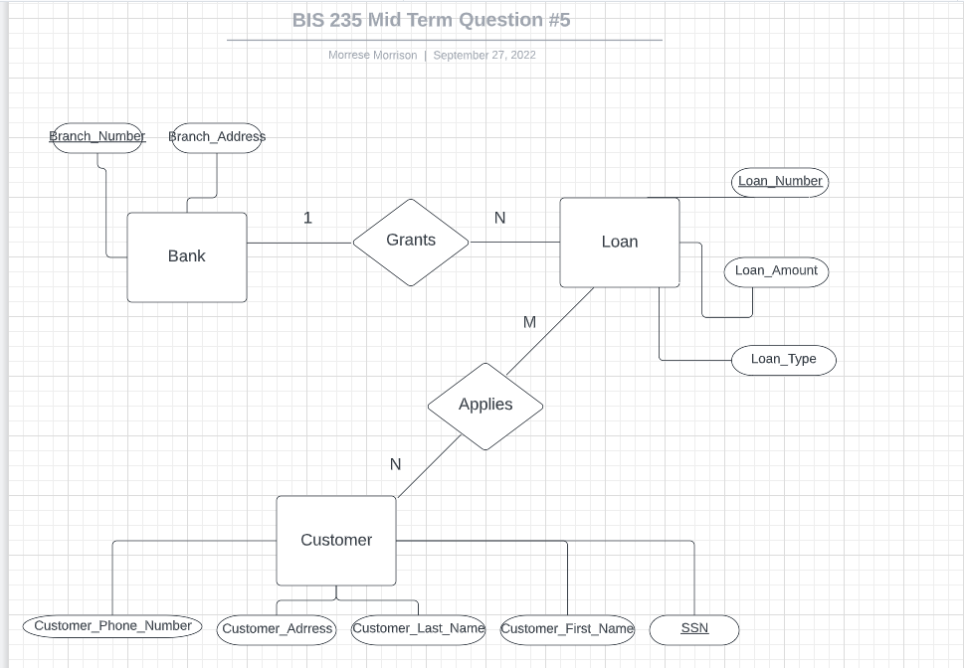

1. **(10 pts) Provide a specific example of the sort of metadata you would find in a relational database management system.**

The type of meta data you would find in a relational database management system is technical metadata. This is data that related to the tables in a database like the table size, any indices and data types.

**Describe succinctly but completely in standard written English what each of the following SQL statements do:**

1. **(5 pts) Select * from employee where salary > 50000 and state IN (‘PA’, ‘NJ’, ‘DE’) order by salary desc;**

Select all records from the employee table where salaries are greater than 50,000 in the state of PA, NJ, and Delaware. These records should be shown in descending order.

1. **(5 pts) Update table employee set salary = salary*1.1 where department < > ‘Corporate’;**

Multiple the salary by 1.1 for any records in the employee table where their department name is not equal to “Corporate”.

1. **(5 pts) Update table employee set department = ‘Corporate’ where department IS NULL;**

**Update all records in the employee table with the department “Corporate” if their current department does not have a department name listed.**

1. **(10 pts) Explain the difference in effect between each of the following 2 pairs of SQL statements:**
   * **Delete from employee; versus Drop table employee;**The difference between both queries is that “DELETE FROM EMPLOYEE” deletes all records from the employee table without deleting the table, while “DROP TABLE EMPLOYEE” completely deletes the table from the database.
   * **Describe table employee; versus Select * from employee;**

The difference between both queries is that “DESCRIBE TABLE” shows the overall structure of the employee table such as the columns within the table as well as the data type of each table and listing any primary keys. “SELECT * FROM Employee” retrieves all records from that table.

For Questions 11 and 11, base your answers on the following table:

Table name: employee

|  |  |  |  |
| --- | --- | --- | --- |
| **Fname** | **Lname** | **Start_date** | **Salary** |
| Hasaan | Patterson | 12-10-2017 | 50000 |
| Marques | Houston | 3-23-2010 | 75000 |
| Felix | Hernandez | 2-19-2012 | 82000 |

1. **(10 pts) Indicate what the result (the “answer”) would be for the following query:**  
     
   Select Fname from employee where Salary > 75000 OR Salary <= 50000;

**Fname:**

Hasaan

1. (10 pts) Indicate what the result (the “answer”) would be for the following query:

Select Lname from employee where DATEDIFF(CURRENT_DATE(),Start_date)/365 > 1 AND Lname LIKE ‘He%’;

**Fname:**

Hernandez